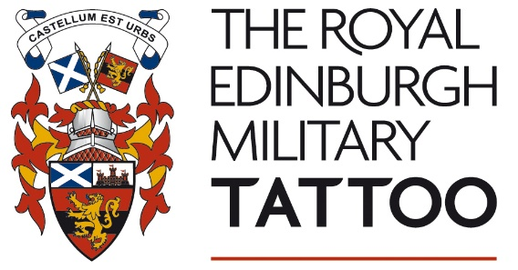
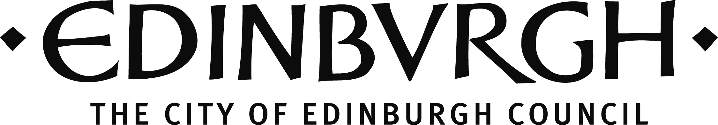

CULTURE PROJECT FUND

PROMOTING ACCESS TO ARTS AND CULTURE
APPLICATION GUIDELINES 2019/20

INTRODUCTION

The City of Edinburgh Council has partnered with The Royal Edinburgh Military Tattoo to stimulate and support artistic and cultural projects that benefit Edinburgh and those who live in and visit the city.

The fund has been developed following on from the City of Edinburgh Council Culture Plan, which has a vision that city partners work together to keep culture and creativity at the heart of Edinburgh’s success and that culture makes a significant contribution to improving Edinburgh’s quality of life, economic vitality and place-making. The Royal Edinburgh Military Tattoo (Charities) Limited aims to “promote and encourage arts, culture and heritage and/or study of the arts, culture and heritage in Edinburgh”.

The aim of this fund in 2019/20 is to address gaps in support available to the arts across the city and the fund will support artist-led projects in Edinburgh, that propose new ways of working to overcome barriers to accessing cultural activity. This can be achieved in a number of ways, including: participatory activity and workshops; Exhibitions or Performances in new spaces across the city; collaborative projects between artists and communities or any other activity which demonstrably meet the purpose of the scheme.

PURPOSE OF SCHEME:

The 2019/20 Culture Project Fund will award grants to organisations undertaking artist-led projects in Edinburgh that extend the reach of arts and cultural engagement and help overcome barriers to access, whether geographic, financial, social or other. Note that the Panel particularly welcomes applications which involve Scottish Traditional Music, instruments and Dance and this will form one of the priorities of the fund (see overleaf).

FUNDS AVAILABLE:

There is an overall fund available of £97,208. Grants awarded are likely to be £5,000 or less, but organisations may be awarded up to £10,000 in exceptional circumstances.

We anticipate a high level of demand for this fund. Applicants should apply for the exact amount needed for their project and will not automatically be awarded the maximum available. Only one application can be submitted per organisation. Organisations already in receipt of funding from the Culture Project Fund may apply but they must have completed and reported on their existing project before a further grant award can be made.

The awards panel reserves the right to offer an amount different from that requested. We strongly encourage applicants to seek partnership support for this project – either in cash or in kind.

DEADLINE:

Friday 10th January 2020. We are unable to accept late applications.

WHO CAN APPLY?

Organisations undertaking artist led projects within the City of Edinburgh boundary.

CRITERIA:

Applications will be assessed against the following criteria:

- The strength of concept and ideas
- The quality of project management
- The extent to which the plans demonstrate partnership working and resource sharing*
- Local and/or city-wide importance of the project**, including who will participate in or otherwise benefit from it
- The difference that this funding will make to the project***.

PRIORITIES:
We will prioritise projects which support partnership working in the cultural and creative sectors; which demonstrate local and/or city-wide importance and which involve Scottish Traditional Music, instruments and dance (note that applicants do not need to meet all priorities in order to be successful). We will also focus on what difference this funding will make to your project.

*Partnership working
The Desire Lines consultation process placed an emphasis on partnership working across the arts and culture sector to make it flourish. In the spirit of this, we are seeking applications which demonstrate partnership contribution, for example: production or technical support; provision of in-kind space or creative input; cash input through funding or commissioning (this list is not exhaustive).

**Local/City-wide importance
The Council’s vision is that “Edinburgh is a thriving, sustainable capital city in which all forms of deprivation and inequality are reduced”.
The Culture Plan vision is that “city partners work together to keep culture and creativity at the heart of Edinburgh’s success”.
We will ask you to tell us how your project addresses one or both of these.

The Council’s Business Plan, with further information on the Vision, can be accessed here: http://www.edinburgh.gov.uk/downloads/file/7115/council_business_plan_-_summary.

The Culture Plan (in its current form) can be accessed here: http://www.edinburgh.gov.uk/meetings/meeting/3812/culture_and_sport_committee

Scottish Traditional Music, Instruments and Dance
Scotland has internationally recognised, rich and distinctive traditional dance and music cultures, encompassing many styles. We will prioritise applications that
encourage a broad range of Edinburgh citizens to participate in or experience traditional dance and music projects and that also address at least one of the above priorities.

***What difference will the funding make?
We will support a wide range of projects which have at their heart a focus on promoting access to cultural activity. We will be assessing the likely impact of the project and to what extent it will extend the reach of cultural activity in the city. We want to see how you propose to use this funding and what you envisage the direct impact of that funding will be. Our focus will be on what major difference this funding will make to the project (i.e. what wouldn’t happen without this support).

EXCLUSIONS:
- We will not consider applications for projects already started or planned to start before the decision is made, unless it is the next stage of a previously completed phase of work.
- Applications will not be considered if received after the deadline date.
- Applications will not be considered unless there is a suitable management/governance structure in place.
- The fund is not intended to support:
  - Revenue costs or permanent posts
  - Press events or launches
  - Equipment items or capital projects
  - Projects which primarily take place outside Edinburgh

HOW TO APPLY:

Please read these guidelines carefully. Applications must be submitted using the application form, returned by the stated deadlines and signed by the applicant. Please contact Lisa Kapur on 0131 529 7988 lisa.kapur@edinburgh.gov.uk if you require advice on your application.

APPLICATION PROCESS AND AWARDS PANEL:

Submitted application forms will be acknowledged via email. Applications will be considered by members of the awards panel, comprising officers from the City of Edinburgh Council and specialist independent advisors, including a representative from The Royal Edinburgh Military Tattoo.

The panel will meet within 8 weeks of the fund deadline and you will be informed in writing of the outcome within one week of the meeting.

Grant Payments

Please allow at least 4 weeks for payments to process. i.e. the project should not aim to start until at least 12 weeks after the fund deadline.

Please send your application to:
Lisa Kapur, Cultural Development Officer, Culture & Events Office, Place Directorate
City of Edinburgh Council, Room 9/47-8, City Chambers, High Street, Edinburgh,
EH1 1YJ

An electronic version to: culturaldevelopment@edinburgh.gov.uk.

If you require this application in Braille, large print, audiotape or disc format, please contact the Cultural Development Team on 0131 529 6720.

