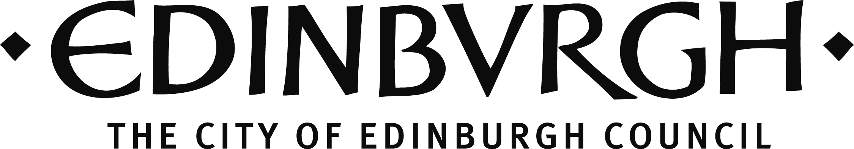

CULTURE PROJECT FUND

PROMOTING ACCESS TO ARTS AND CULTURE
APPLICATION GUIDELINES 2019/20

Please read the application guidelines before completing the form. Please do not fax, bind or present it in any other format.

Section 1: Organisation Details
Organisation name
Contact Address

Postcode
Contact Name & Position
Phone
Contact E-mail
Organisation’s website
Facebook url
Twitter account
Please confirm your organisation is formally constituted
(Please note that we can only accept applications from constituted organisations)
Yes my organisation is formally constituted:
Overview of Organisation (including main aims and objectives):

(* by submitting your email address you are authorising us to add you on to the City of Edinburgh Council cultural development database. This database is used to keep individuals and organisations up-to-date on other potential funding streams. Please tick this box if you do not wish to be added on to this database ).

Section 2: Your Application

Project name & description as it will appear in any publicity (25 words):
Project dates: (Note: Applications will not be considered for projects/stages in projects already started or planned to start, before the panel meeting date):
Start date: | Finish date:
If the project relates to a specific event or performance, please indicate:
Date(s) / Time of the event
Venue(s)
Where will your activity take place? (list all locations & include postcodes, where known):
Partner Organisation(s) involved in this project:
How will the project be led and managed? Please give an indication of the management structure for the project. (200 words)

Please describe the project you are seeking funding for (Refer to the Guidelines for support to complete this section and limit answers in each box to 150 words):
Describe your project and the thinking behind it:

Tell us how this project demonstrates local and/or citywide importance

Tell us how this project will extend the reach of arts and cultural engagement in the city and help overcome barriers to accessing it

Tell us how this project will improve or develop partnership working (as described in the guidelines)

What difference will this funding make to your project?

Who will benefit from your proposal?

Section 3: Budget

Budget
Details of the budget associated with this project/proposal including a clear statement of partnership funding (either secured, pending confirmation or to be applied for), in-kind contributions and your VAT status. Both income and expenditure should be listed.

Amount requested from Project fund: | £
Expenditure
Breakdown of Estimated Project Costs

item | cost £ | Cash or in-kind
Total Estimated Cost of Project

Income
sources of income |  | £ | Confirmed  Cash or in-kind
Total Estimated Income for Project
(this figure should equal your expenditure above)
Please attach a copy of your most recent annual (approved/audited) accounts. If your organisation is newly constituted, the most recent bank statement will suffice. Please also provide a copy of your constitution.
Have you enclosed your accounts/bank statement?  Have you enclosed a copy of your constitution? | YES/NO  YES/NO

DECLARATION
All applications must be confirmed by two people who are recognised as representatives of your organisation. One of these people must be a board/management committee member.
You are being asked to declare that:
- to the best of your knowledge the information contained in this application, and any accompanying documents, is accurate.

Principal Contact:
Name
Position
Secondary Contact:
Name
Position
e-mail
phone

DEADLINE: Friday 10th January 2020. We are unable to accept late applications.
Please send your application to:

Lisa Kapur, Cultural Development Officer, Culture Service, City of Edinburgh Council
City of Edinburgh Council | Room 9/47-8, City Chambers, High Street, Edinburgh, EH1 1YJ
0131 529 7988

An electronic version to: culturaldevelopment@edinburgh.gov.uk

